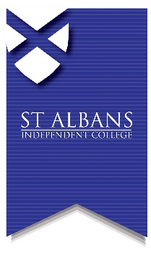
St. Albans Independent College,
69 London Road,
St. Albans, Herts, AL1 1LN
t: 01727 842348
e: exams@stalbanscollege.co.uk
w: www.stalbanscollege.co.uk

PRIVATE CANDIDATE EXAM ENTRY FORM (GCSE/IGCSE)

Candidate Full Name: |  | Male: Female:
Address: |  | Post Code:
Tel 1: | Tel 2: | Date  of birth:
Candidate email address:

Parent email address, if appropriate:

Exam Session:

May / June: Year:

If you have sat public examinations before, please state your UCI number found on previous exam result slips(12 digits and one letter): | Have you sat exams at  St Albans Independent College in the past?  Yes: No:
Do you have any access

arrangements during exams? No: Extra Time: Use of PC: Other:

Please note that access arrangements can only be granted subject to meeting the current regulations laid down by Joint Council for Qualifications (JCQ).

Subject:  Please state if GCSE or IGCSE | Exam Board | Subject Code | Higher    () | Foundation    ()
Where are you studying for these exams?

Current School: Independently: Private Tutor: Distance Learning: Other:

Please give details:

Candidate signature or parent signature (as appropriate): | Date:

