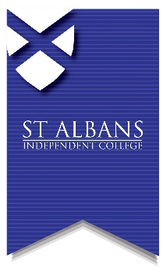
St. Albans Independent College,
69 London Road,
St. Albans, Herts, AL1 1LN
t: 01727 842348
e: exams@stalbanscollege.co.uk
w: www.stalbanscollege.co.uk
PRIVATE CANDIDATE ENTRY FORM (A-LEVEL)

Candidate Full Name: |  |  |  |  |  | Male: Female:
Address: |  |  |  |  |  | Post Code:
Tel 1: |  | Tel 2: |  |  |  | Date  of birth:
Candidate email address:

Parent email address, if appropriate:
Exam Session:

May/June: Year:
If you have sat public examinations before, please state your UCI number found on previous exam result slips (12 digits and one letter): |  |  |  |  | Have you sat exams at  St. Albans Independent College in the past?  Yes: No:
Do you have any access

arrangements during exams? No: Extra Time: Use of PC: Other:

Please note that access arrangements can only be granted subject to meeting the current regulations laid down by Joint Council for Qualifications (JCQ).

 | Subject |  | Exam Board | Subject Code
A LEVEL

A LEVEL

A LEVEL

AS LEVEL
AS LEVEL
AS LEVEL
Where are you studying for these exams?

Current School: Previous School: Private Tutor: Distance Learning: Other:

Please give contact details:

Candidate signature or parent signature (as appropriate): |  |  |  |  |  |  | Date:

